**Images of Pixels Plotted**

Below, plotted images in order of increasing wavelength. The **purple dots** plotted show successful, perfect fits. The **red dot** is the original pixel I tested where I could not make a perfect fit. NOTE I CAN fit pixels *next to* (1 pixel to right / left) of that red dot.

Hα:

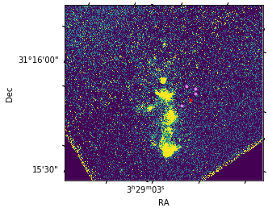

1.26: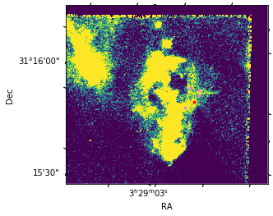

1.28:

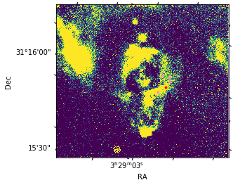

1.64: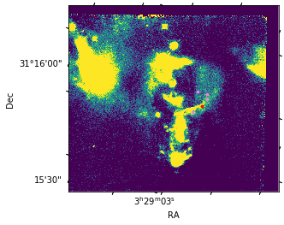

**Blackbody Fits**

Fitting the blackbody fits…labeling the regions by number:

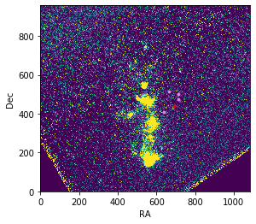

1

2

3

4

5

Table of fit properties:

|  |  |  |
| --- | --- | --- |
| Region # | T (K) | C |
| 1 | 4.18739155e+03 | 6.30258435e-24 |
| 2 | 5.13146882e+03 | 2.04852698e-24 |
| 3 | 3.00545330e+04 | 2.12119272e-25 |
| 4 | 3.56578721e+03 | 1.36161449e-23 |
| 4 (1 pix right, up) | 8.26237724e+03 | 1.87543255e-24 |
| 4 (1 pix left, up) | 5.09903288e+03 | 5.13022565e-24 |
| 5 | 5.40730961e+03 | 5.39241732e-24 |

Blackbody plots (same order as table):

1…

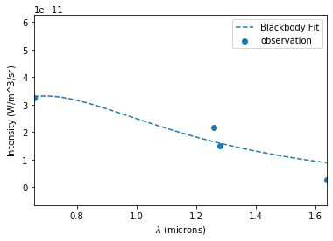

2…

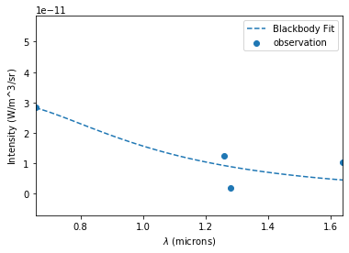

3…

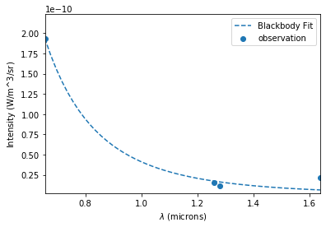

4…

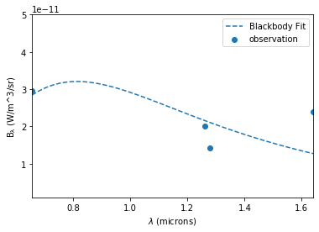

4, 1 pix up, right…

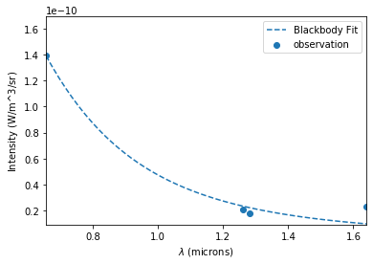

4, 1 pix left, up…

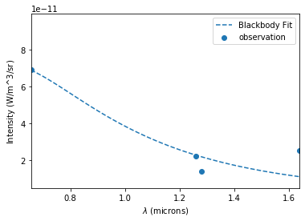

5…

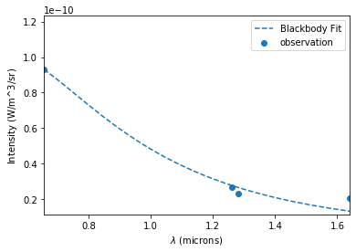

**Fitting Non-Lin Equs for Multiple Pixels**

For each pixel, I *fit by scipy curve_fit* (except for the original pixel I was trying to and failing to fit perfectly…). Newton-krylov will converge to a similar but slightly more accurate value from my tests on the one pixel that didn’t fit, but it is slower to do that, so I’m doing this for efficiency. I consider a fit with the sum of squares is ~1E-40 to 1E-50 (and I can’t distinguish the points on the plot):

|  |  |  |  |  |  |
| --- | --- | --- | --- | --- | --- |
| Fit Parameter | C | AV | fH | fFe | Σ(squares) |
| 1 | 1.23092420e-25 | -16.0909485 | -3.67251890e-14 | 1.11616659e-14 | 1.0823979396786784e-45 |
| 2 | -1.63177894e-23 | 4.91608297 | 7.77976415e-11 | 5.93311494e-11 | 7.0473288254384065e-53 |
| 3 | -1.61366973e-24 | 2.23233290 | 1.43044186e-10 | 7.87134333e-11 | 1.1797750478141332e-51 |
| 4 | -1.97416054e-23 | 5.23938071 | 8.62153822e-11 | 6.25492719e-11 | 4.607205358862025e-23 |
| 4 (1 pix right, up) | -1.57759310e-23 | 4.10464801 | 2.39356853e-10 | 1.28828116e-10 | 1.2319774835581214e-51 |
| 4 (1 pix left, up) | -2.29099942e-22 | 7.22270364e | 1.06816911e-09 | 5.82845407e-10 | 2.3491096084794688e-51 |
| 5 | -1.24016029e-23 | 4.08133199 | 1.25824740e-10 | 7.03554475e-11 | 1.5556325851708482e-51 |

Intensity Plots of Fits (same order):

1…

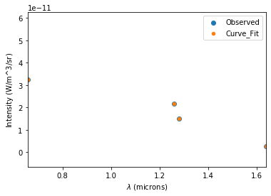

2…

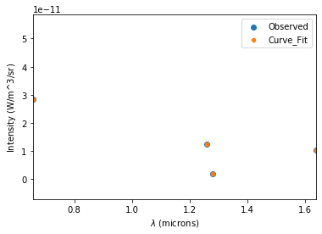

3…

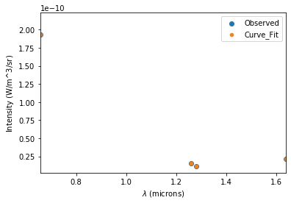

4…

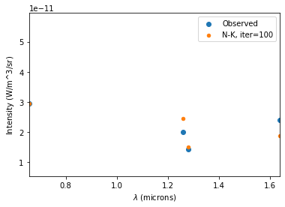

4, 1 pix right, up…

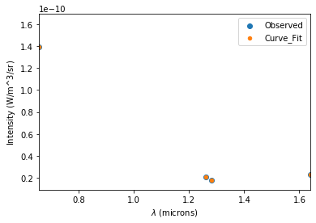

4, 1 pix left, up…

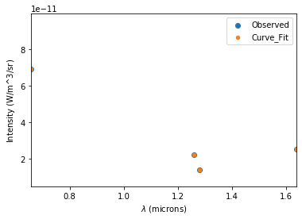

5…

